Quiz 5
Section C
Apply dijstra algorithm for node A. Follow the format and construct its forwarding table. (10 Marks)
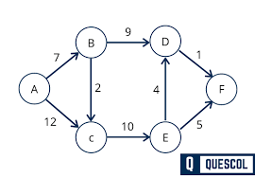
Question 2 ( 5 Marks)
A router output port receives packets from two traffic classes:
- Class 1 = High Priority
- Class 2 = Low Priority
Packets arrive at the output queue in the following order:
Arrival Time | Class | Packet ID | Size
0 ms | Class 2 | P1 | 400 bytes
1 ms | Class 1 | P2 | 300 bytes
2 ms | Class 2 | P3 | 200 bytes
3 ms | Class 1 | P4 | 300 bytes
Assume link transmission rate is 1 byte per millisecond, and once transmission of a packet starts, it cannot be interrupted.
Draw the transmission timeline if the router uses Strict Priority Scheduling (Class 1 > Class 2).
